SOUND PAST EXAM BOOKLET

Contents

Syllabus Points 2

Longitudinal and transverse waves - 10.1 3

2021 3

Representing Waves 10.2 4

2015 4

2019 5

2021 6

2019 8

Wave Behaviour 10.3 13

2016 13

2015 14

2020 15

2023 16

2018 COMPREHENSION 17

2022 21

Standing waves and harmonics - 10.5 25

2015 25

2017 26

2018 28

2019 30

2020 32

2022 35

2016 COMPREHENSION 36

2021 COMPREHENSION 39

2015 COMPREHENSION 43

Wave Intensity & Applications Of Wave Properties - 10.6 46

2017 46

2021 46

2018 47

2019 48

2020 49

2022 49

2016 COMPREHENSION 50

# Syllabus Points

# Longitudinal and transverse waves - 10.1

## 2021

2022

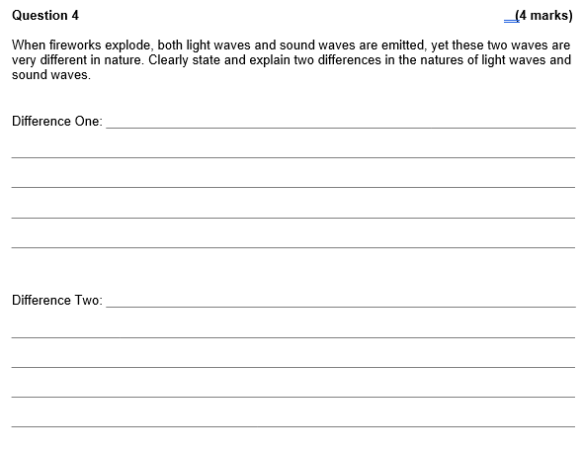

# Representing Waves 10.2

## 2015

## 2019

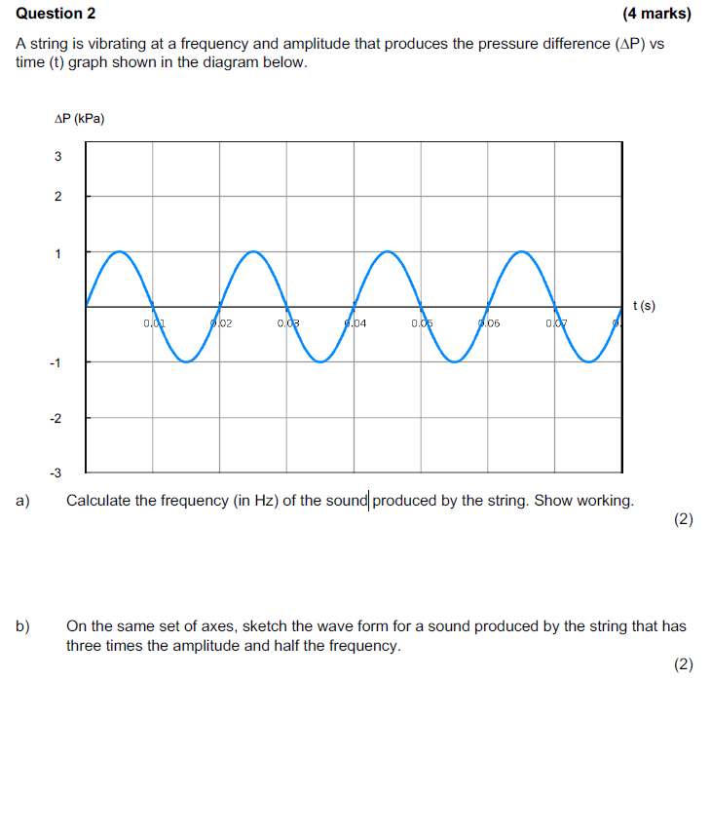

## 2021

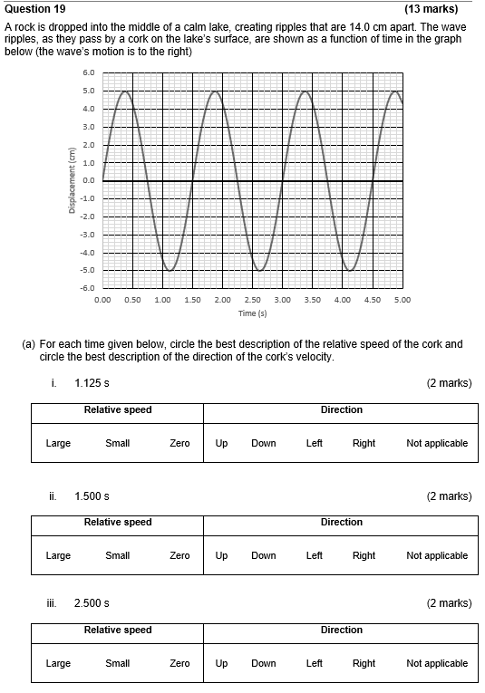

## 2019

# Wave Behaviour 10.3

## 2016

## 2015

## 2020

## 2023

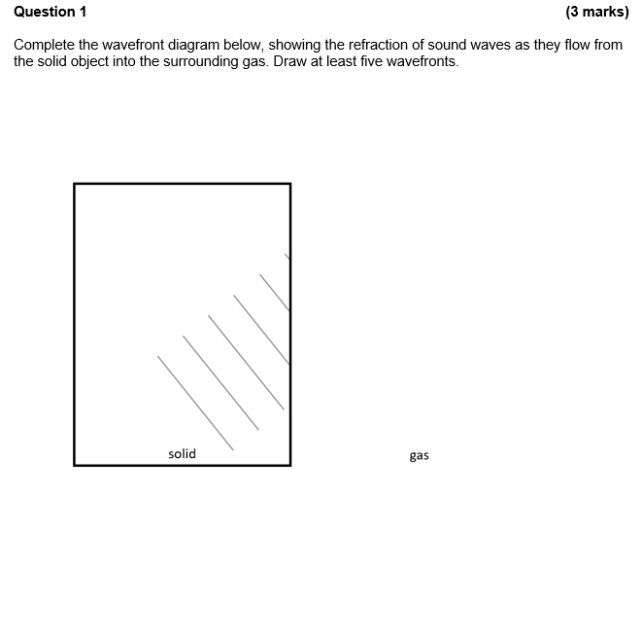

## 2018 COMPREHENSION

## 2022

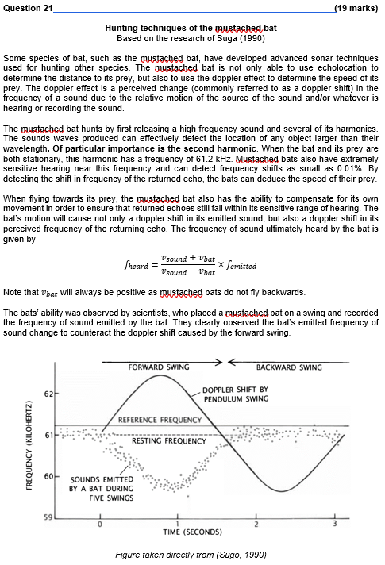

# Standing waves and harmonics - 10.5

## 2015

## 2017

## 2018

## 2019

## 2020

## 2022

## 2016 COMPREHENSION

## 2021 COMPREHENSION

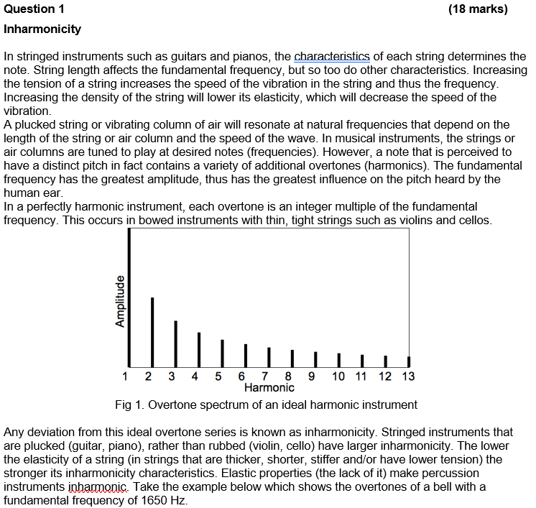

## 2015 COMPREHENSION

# Wave Intensity & Applications Of Wave Properties - 10.6

## 2017

## 2021

## 2018

## 2019

## 2020

## 2022

## 2016 COMPREHENSION

